ACIDS (Non-oxidizing)
STANDARD OPERATING PROCEDURE TEMPLATE
Type of SOP: Process Hazardous Chemical Hazard Class
To customize this SOP, add lab-specific information to the sections below marked in RED, as applicable. Completion of the last section (“Lab-Specific Information”) is required. Also, any of the content below may be amended with lab-specific information to enhance worker safety as desired.

- HAZARD OVERVIEW
Acids are corrosive to eyes, skin, and mucous membrane and are generally immediately painful. Corrosive effects can occur not only on the skin and eyes, but also in the respiratory tract and, in the case of ingestion, in the gastrointestinal tract as well. The international symbol (GHS system) for a corrosive to skin/eyes (acid or base) is:
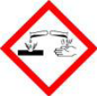
The pH range of acids is 0 to 6.9 (water = 7.0 = neutral). A pH of approximately 0 to 3 represents a strong acid. Some inorganic acids fall within this range. Weak acids (pH of 3 to 7) include diluted acetic acid solutions and boric acid. Weak acids irritate the skin with short contact and can cause burns with prolonged contact.
Heat is released when strong acids are mixed with water. When water is added to acid, an extremely concentrated solution of acid is initially formed and the solution may boil very violently, splashing concentrated acid. When acid is added to water, the solution formed is dilute and the small amount of heat released is not significant to vaporize and spatter it. Always add acid to water, and never the reverse. Aqueous solutions of inorganic acids are not in themselves flammable. Acids also react with many metals, resulting in the liberation of hydrogen, a highly flammable gas.
Some acids like nitric and perchloric are strong oxidizing agents and can react destructively and violently when in contact with organic solvents and organic acids like acetic. Due to the unique and highly reactive nature of oxidizing acids, there are separate UCSB SOP templates for nitric and perchloric acids that labs should adopt. Numerous accidents have occurred on campus via the mishandling of nitric acid. There is also a separate SOP for hydrofluoric acid given its unique hazards
- HAZARDOUS NON-OXIDIZING ACIDS
All acid solutions are considered hazardous. The following is a list of the common non-oxidizing acids used: hydrobromic acid; hydrochloric; hydrofluoric; acetic; benzoic; chloroacetic; formic; phosphoric; sulfuric; trifluroacetic

- PERSONAL PROTECTIVE EQUIPMENT (PPE)

Given the severe and immediate effects of acids on the eyes and skin, it is essential that proper PPE always be employed. This is the law and UC policy.

See the PPE information under Sec. II of the UCSB Chemical Hygiene Plan regarding:
- the UC PPE Policy and policy summary (what a PPE is needed and when/where to use)
- obtaining your PPE via use of the Laboratory Hazard Assessment Tool
- glove selection criteria
- respirator use, etc.

- ENGINEERING/VENTILATION CONTROLS

In general, acids should always be used in a properly functioning fume hood.

For further information see these pages in Sec. II of the UCSB Chemical Hygiene Plan:
- Fume Hood Usage Guide
- Criteria for Implementing Engineering Controls

- SPECIAL HANDLING PROCEDURES AND STORAGE REQUIREMENTS
Acids can be only used in areas properly equipped with a certified eye wash/safety shower that can be reached within ten seconds. It is essential that all strong corrosives be stored separately from other laboratory chemicals with which they may react. Ensure secondary containment and segregation of incompatible chemicals. Also, follow any substance-specific storage guidance provided in Safety Data Sheet (SDS) documentation.
The corrosive properties of these materials and their ability to produce fires or explosions by combination with combustible materials make the following considerations mandatory in the selection of a storage site:
- A relatively cool, dry environment free from extremes of temperature--humidity should be maintained.
- Acids must be stored in a manner that separates them from other materials
- Stored acids in material that is acid-resistant; this facilitates flushing and other cleanup procedures in the event of leaks or spills.
- Store on low shelves or in acid/base storage cabinets.
- Segregate oxidizing acids from organic acids, and flammable and combustible liquids. This is crucial to avoid fires/explosions!
- Segregate acids from active metals such as sodium, potassium, magnesium, etc.

- Use bottle carriers for transporting materials when possible.
- When mixing acids and water, always add acid to water. NEVER add water to acid!
- Store mineral acids together, separate from oxidizing agents and organic materials.
- Store acetic acid and other organic acids with the combustible organic liquids.

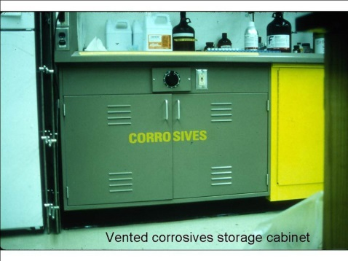

- SPILL AND INCIDENT PROCEDURES
See directions under the “Chemical Incident” and “Medical Emergency” tabs of the UCSB Emergency Information Flipchart – should already be posted in all labs.
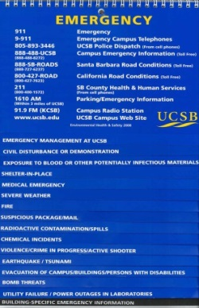

- DECONTAMINATION
Wear proper PPE, decontaminate equipment and bench tops using sodium bicarbonate and water. Dispose of all used contaminated disposables as hazardous waste following the Waste Disposal Section.

- WASTE DISPOSAL
See “Chemical Waste Disposal” in Sec. II of the UCSB Chemical Hygiene Plan.

- PRIOR APPROVAL/REVIEW
None.

- DESIGNATED USE AREA
Lab space in Noble 2224, including fume hood, east tables, and lab benches. Tables on the west wall are no-chemical areas.

- SAFETY DATA SHEETS
Found online at: http://ehs.ucsb.edu/labsafety/msds

- LAB-SPECIFIC INFORMATION (required) (Examples of appropriate content)

Add appropriate lab-specific information here describing how this material(s) is generally used. E.g., name of protocol, typical frequency done, quantities used, temperature and any additional safety measures, etc.

